Prairieland Parish
9th Sunday after Pentecost
Prelude – Welcome – Announcements
Today’s Scripture passage is the Parable of the mustard seed, yeast, hidden treasure and the net. The inspiring words Jesus can guide us in our lives to share the good news to others.
Call to Worship
Even though we may seem like a small church, we can become important in the life of the community around us. Today’s parables offer us different ideas on how we can participate in growing your kingdom. Your final words on Earth before you ascended into heaven were for us to go and make disciples of all nations. Thank you for sharing so many examples.
Like yeast all we have to do is mix in with others to help them grow in faith
A hidden treasure only benefits the one who finds it if that person does not share it.
Like a net that is lowered down to catch whatever swims into it, we too can go out into the world and bring the good news to others to grow God’s kingdom
PRAYER OF CONFESSION
Lord Jesus, you gave so many parables to help the people understand better how the kingdom of God is. As today’s passage ends, even though we may not look at ourselves as a teacher of the law, we are disciples in the kingdom of heaven and as the caretaker of your house here at this church, give us the courage to bring out all the new treasures as well as the old, to share with others all we can.
Assurance of God’s care for us
Your parables so graciously show just how much our Heavenly Father offers so many ways for all to be accepted into heaven to be with you. Help us to not be afraid to let others know of your unconditional love.
PRAISE HYMN UMH #133 Leaning on the Everlasting Arms
The Word of GOD
GOSPEL LESSON………………….……..…………Matthew 13: 31-33, 44-52
THE WORD OF GOD FOR THE PEOPLE OF GOD!
THANKS BE TO GOD
Children’s Time
FAITH HYMN UMH #110 A Mighty Fortress Is Our God
Message
PRAYERS FOR THE PEOPLE – THE LORD’S PRAYER
OFFERING/DOXOLOGY/PRAYER
DEPARTING HYMN #569 We’ve a Story to Tell the Nations
DEPARTING WORDS:
As we depart, know that you are now entering the mission field. Be ever watchful for the opportunities God places before you. Go with the confidence that where God may lead you, you can lean on him should you have to. Be bold to tell the story of the wonders of God to those that you will meet along the way of life.
POSTLUDE (you are welcome to remain to listen to the postlude)

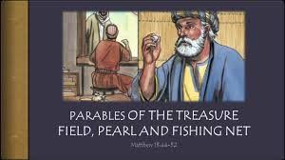

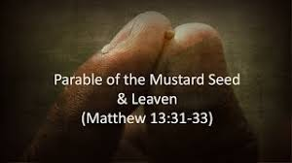

July 26, 2026

